Images of birds recorded at Sengulam
(Photo credits: NKS- Naveen Kumar S; AR- Arun Ram; SBK- Sureshbabu K)
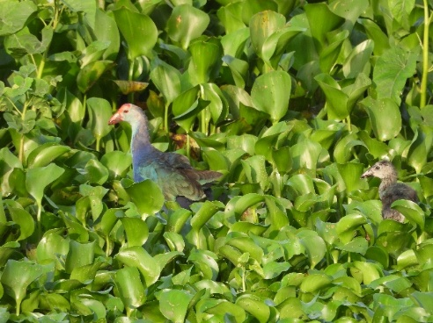
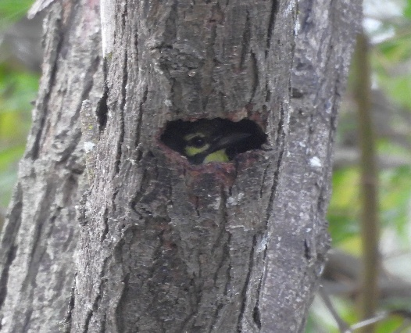

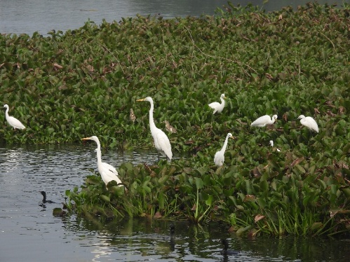
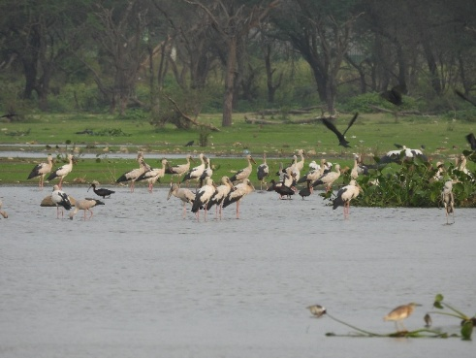
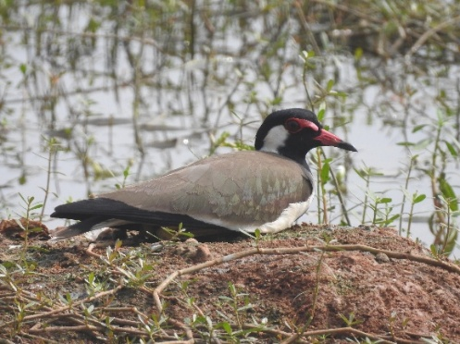
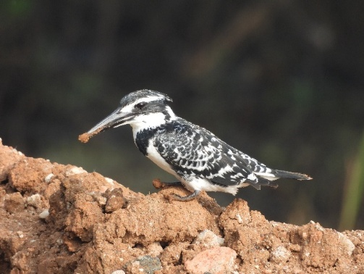
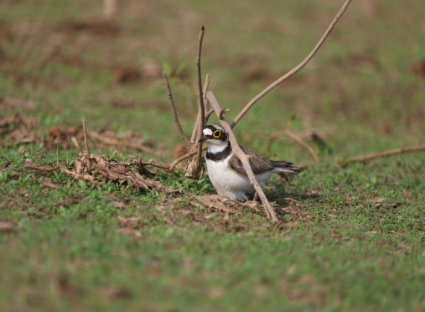
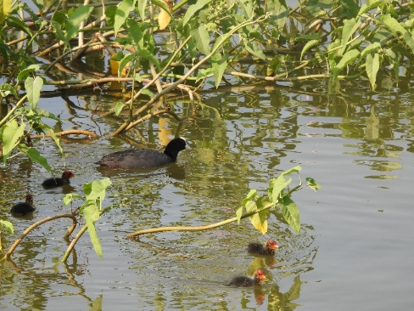
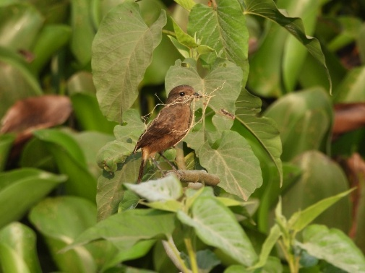
Flock of Painted Storks, Glossy Ibis and other waterbirds

Psilopogon haemacephalus
Flock of Whiskered Terns
Flock of Egrets

Psilopogon haemacephalus
Red-wattled Lapwing
Vanellus indicus
Psilopogon haemacephalus
Pied Kingfisher
Ceryle rudis
Psilopogon haemacephalus
Little Ringed Plover
Charadrius dubius
Psilopogon haemacephalus
Eurasian Coot
Fulica atra
Psilopogon haemacephalus
Grey-headed Swamphen Porphyrio poliocephalus
Coppersmith Barbet
Psilopogon haemacephalus

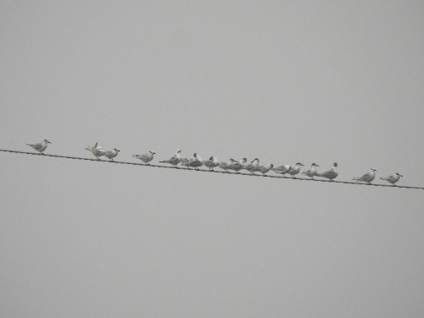
Pied Bushchat
Saxicola caprata

Psilopogon haemacephalus
©NKS
©NKS
©NKS
©NKS
©AR
©NKS
©SBK
©NKS
©NKS
©NKS
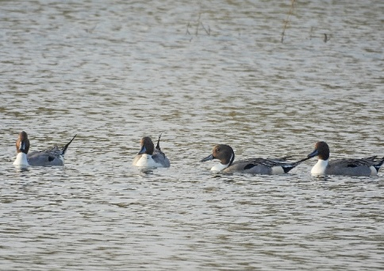
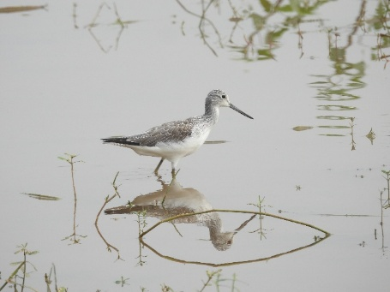
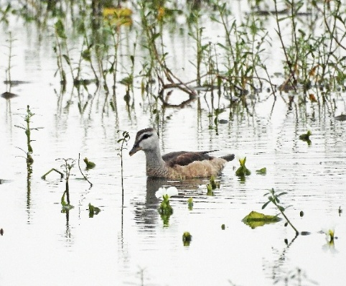
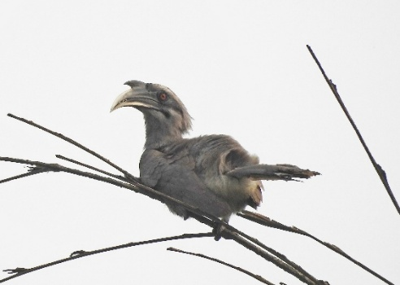
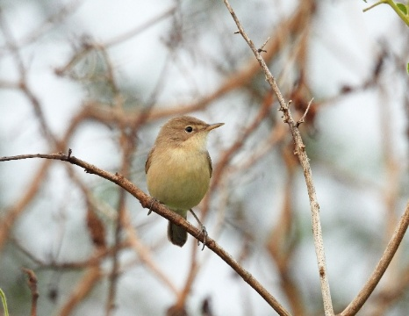
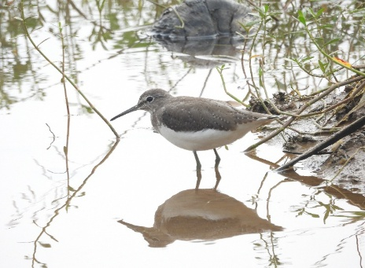
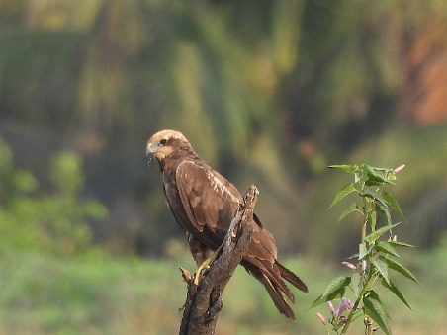
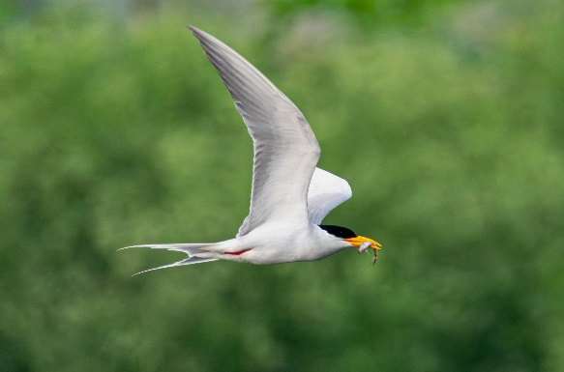
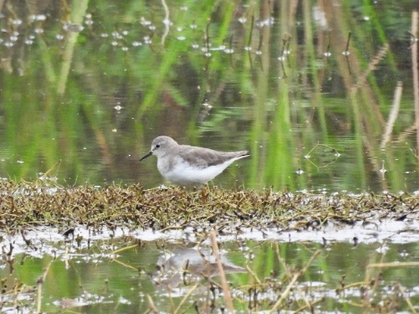
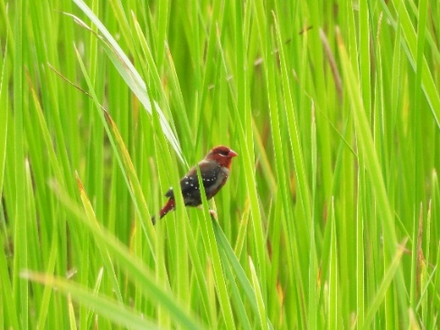
©NKS
River Tern
Sterna aurantia
Psilopogon haemacephalus
Red Avadavat
Amandava amandava
Psilopogon haemacephalus
Green Sandpiper
Tringa ochropus
Indian Grey Hornbill
Ocyceros birostris
Psilopogon haemacephalus
©NKS
©NKS
©NKS
©RKS
©NKS
©NKS
©NKS
©NKS
©NKS
Temminck’s Stint
Calidris temminckii
Psilopogon haemacephalus
Cotton Pygmy Goose
Nettapus coromandelianus
Psilopogon haemacephalus
Booted Warbler
Iduna caligata
Psilopogon haemacephalus
Western Marsh Harrier
Circus aeruginosus
Psilopogon haemacephalus
Common Greenshank
Tringa nebularia
Psilopogon haemacephalus
Northern Pintail
Anas acuta
Psilopogon haemacephalus
Images of threats observed at Sengulam

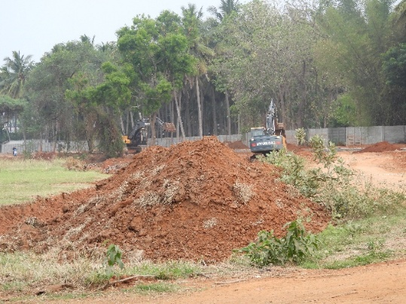


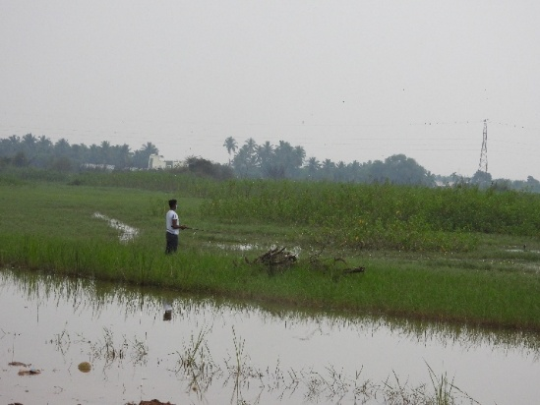
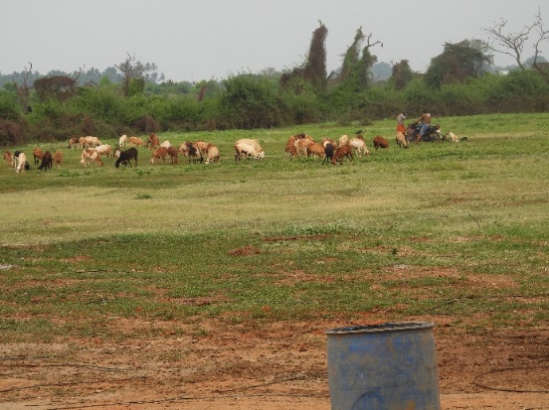
©NKS
©NKS
©NKS
©NKS
©NKS
©NKS
